**1. What is the trend of migration (increasing or decreasing) in Myanmar?**

**on the perspective of migrant or non-migrant households, village heads, administrative staffs**

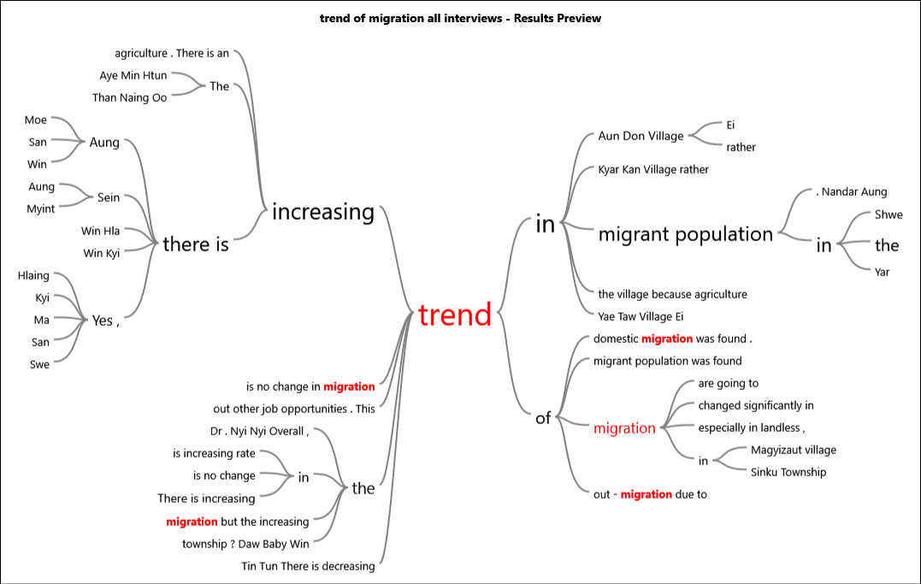

Figure 1 Text search query for trend of migrant population

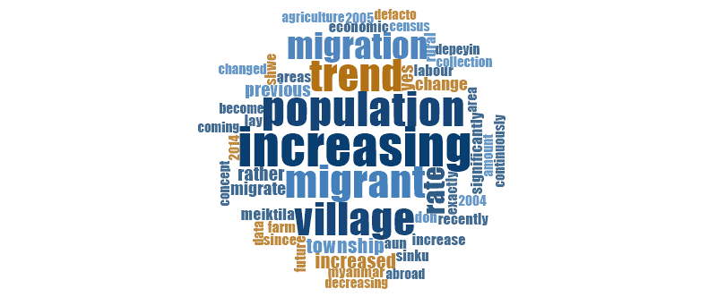

Figure 2 Word frequency query in coding of increasing, decreasing and on change

Table 1 Matrix query for the trend of migrant population by different attributes

|  |  |  |  |
| --- | --- | --- | --- |
|  | A : Decreasing | B : Increasing trend | C : No change |
| 1 : Person:Gender = Male | 1 | 32 | 2 |
| 2 : Person:Gender = Female | 0 | 12 | 2 |
| 3 : Person:Participant type = Migrant | 0 | 10 | 2 |
| 4 : Person:Participant type = Non Migrant | 0 | 11 | 1 |
| 5 : Person:Participant type = Village Head | 1 | 10 | 1 |
| 6 : Person:Participant type = Head Level officer | 0 | 4 | 0 |
| 7 : Person:Participant type = Township level officer | 0 | 9 | 0 |

Table 2 Crosstab query result for different participants through gender

|  |  |  |  |  |  |
| --- | --- | --- | --- | --- | --- |
| Person | | Decreasing | Increasing trend | No change | **Total (unique)** |
| Gender = Male (35) |  |  |  |  |  |
|  | Participant type = Migrant (2) | 0 | 2 | 0 | 2 |
|  | Participant type = Non Migrant (10) | 0 | 9 | 1 | 10 |
|  | Participant type = Village Head (12) | 1 | 10 | 1 | 12 |
|  | Participant type = Head Level officer (3) | 0 | 3 | 0 | 3 |
|  | Participant type = Township level officer (8) | 0 | 7 | 0 | 7 |
| Gender = Female (15) |  |  |  |  |  |
|  | Participant type = Migrant (9) | 0 | 8 | 2 | 9 |
|  | Participant type = Non Migrant (3) | 0 | 2 | 0 | 2 |
|  | Participant type = Village Head (0) | 0 | 0 | 0 | 0 |
|  | Participant type = Head Level officer (1) | 0 | 0 | 0 | 0 |
|  | Participant type = Township level officer (2) | 0 | 2 | 0 | 2 |
| Total |  |  |  |  |  |
|  | **Total (50)** | 1 | 43 | 4 | 47 |

**Why do migrants decide to move to other place?**

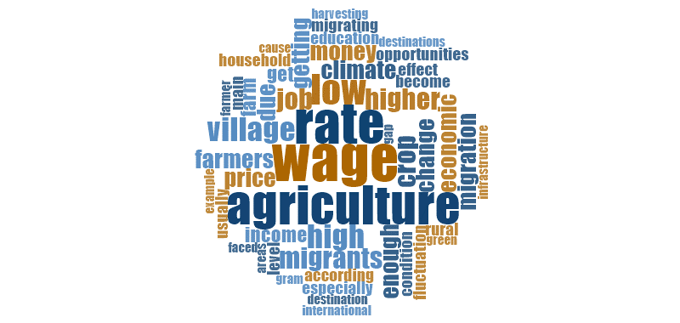

Figure 3 word count frequency for reason of migration code.

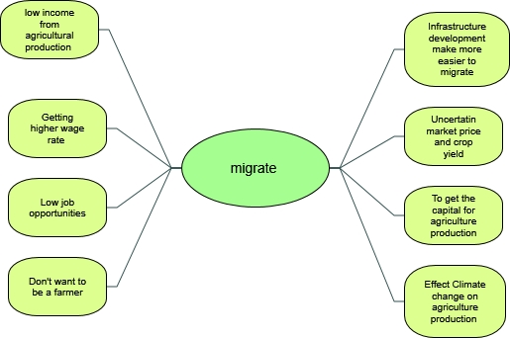

Figure 4 Mind map of why migrants decided to migrate

**Step by step process of international and domestic migration.**

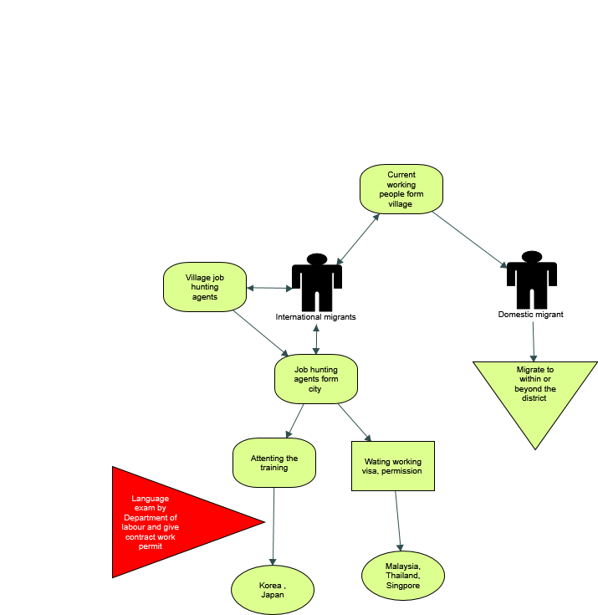

Figure 5 step by step process for international and domestic migration

**Who made the decision to include in migration?**

Table 3 who made the decision to include in migration process through gender and migration status

|  |  |  |  |  |
| --- | --- | --- | --- | --- |
|  | A : Person:Gender = Male | B : Person:Gender = Female | C : Person:Participant type = Migrant | D : Person:Participant type = Non Migrant |
| 1 : By themselves | 1 | 1 | 2 | 0 |
| 2 : Family together | 3 | 3 | 4 | 2 |
| 3 : Household head (Father) | 3 | 2 | 2 | 3 |
| 4 : Parents | 2 | 1 | 0 | 3 |
| 5 : Wife | 1 | 1 | 2 | 0 |

**What kind of people or families are involving in migration process?**

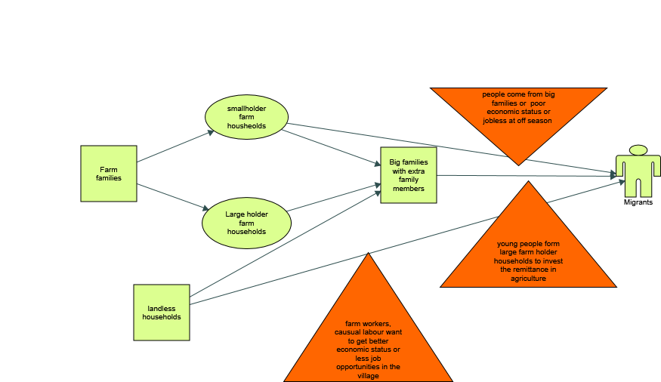

Figure 6 Mind map for kind of families involving in migration process

Table 4 kind of families involving in migration process

|  |  |  |  |  |  |  |  |  |  |  |
| --- | --- | --- | --- | --- | --- | --- | --- | --- | --- | --- |
| Person | | Large farm assets | Medium farm assets | Small farm assets | Big households | Farm households | Jobless people | Nonfarm households | Poor households | **Total (unique)** |
| Gender = Male (35) |  |  |  |  |  |  |  |  |  |  |
|  | Participant type = Migrant (2) | 2 | 0 | 2 | 0 | 2 | 0 | 2 | 1 | 2 |
|  | Participant type = Non Migrant (10) | 1 | 1 | 5 | 5 | 5 | 0 | 5 | 3 | 10 |
|  | Participant type = Village Head (12) | 3 | 0 | 9 | 1 | 11 | 0 | 7 | 1 | 12 |
|  | Participant type = Head Level officer (3) | 0 | 0 | 0 | 0 | 0 | 0 | 0 | 0 | 0 |
|  | Participant type = Township level officer (8) | 0 | 0 | 2 | 1 | 2 | 0 | 3 | 1 | 4 |
| Gender = Female (15) |  |  |  |  |  |  |  |  |  |  |
|  | Participant type = Migrant (9) | 1 | 0 | 5 | 1 | 8 | 1 | 7 | 2 | 9 |
|  | Participant type = Non Migrant (3) | 1 | 0 | 1 | 2 | 1 | 1 | 0 | 0 | 2 |
|  | Participant type = Village Head (0) | 0 | 0 | 0 | 0 | 0 | 0 | 0 | 0 | 0 |
|  | Participant type = Head Level officer (1) | 0 | 0 | 0 | 0 | 0 | 0 | 0 | 0 | 0 |
|  | Participant type = Township level officer (2) | 0 | 0 | 0 | 0 | 0 | 0 | 0 | 0 | 0 |
| Total |  |  |  |  |  |  |  |  |  |  |
|  | **Total (50)** | 8 | 1 | 24 | 10 | 29 | 2 | 24 | 8 | 39 |

**What are migrants’ characteristics?**

Table 5 migrants’ education through occupation

|  |  |  |  |  |
| --- | --- | --- | --- | --- |
| Person | High school level | Primary school level | Secondary school level | **Total (unique)** |
| Occupation = Farmer (25) | 10 | 7 | 14 | 21 |
| Occupation = Village Head (12) | 6 | 4 | 5 | 11 |
| Occupation = Officer (4) | 0 | 0 | 0 | 0 |
| Occupation = Manager (5) | 0 | 0 | 0 | 0 |
| Occupation = Deputy Director General (3) | 1 | 1 | 0 | 1 |
| Occupation = Director General (1) | 0 | 0 | 0 | 0 |
| **Total (50)** | 17 | 12 | 19 | 33 |

Table 6 migrants’ education by gender and participant types

|  |  |  |  |  |  |
| --- | --- | --- | --- | --- | --- |
| Person | | High school level | Primary school level | Secondary school level | **Total (unique)** |
| Gender = Male (35) |  |  |  |  |  |
|  | Participant type = Migrant (2) | 0 | 1 | 1 | 1 |
|  | Participant type = Non Migrant (10) | 4 | 2 | 7 | 9 |
|  | Participant type = Village Head (12) | 6 | 4 | 5 | 11 |
|  | Participant type = Head Level officer (3) | 0 | 0 | 0 | 0 |
|  | Participant type = Township level officer (8) | 0 | 0 | 0 | 0 |
| Gender = Female (15) |  |  |  |  |  |
|  | Participant type = Migrant (9) | 4 | 4 | 5 | 9 |
|  | Participant type = Non Migrant (3) | 2 | 0 | 1 | 2 |
|  | Participant type = Village Head (0) | 0 | 0 | 0 | 0 |
|  | Participant type = Head Level officer (1) | 1 | 1 | 0 | 1 |
|  | Participant type = Township level officer (2) | 0 | 0 | 0 | 0 |
| Total |  |  |  |  |  |
|  | **Total (50)** | 17 | 12 | 19 | 33 |

Table 7 Gender of migrant base on township types

|  |  |  |  |  |
| --- | --- | --- | --- | --- |
| Person | Equal ratio | Female greater than male | Male greater than Female | **Total (unique)** |
| Township = Monya (11) | 0 | 2 | 6 | 8 |
| Township = Depeyin (10) | 1 | 5 | 5 | 8 |
| Township = Sinku (12) | 3 | 2 | 7 | 11 |
| Township = Meiktila (13) | 4 | 1 | 4 | 9 |
| Township = Nay Pyi Taw (4) | 0 | 0 | 0 | 0 |
| **Total (50)** | 8 | 10 | 22 | 36 |

Table 8 Migrants’ gender by gender and participant types

|  |  |  |  |  |  |
| --- | --- | --- | --- | --- | --- |
| Person | | Equal ratio | Female greater than male | Male greater than Female | **Total (unique)** |
| Gender = Male (35) |  |  |  |  |  |
|  | Participant type = Migrant (2) | 1 | 0 | 1 | 2 |
|  | Participant type = Non Migrant (10) | 2 | 3 | 7 | 10 |
|  | Participant type = Village Head (12) | 2 | 4 | 7 | 12 |
|  | Participant type = Head Level officer (3) | 0 | 0 | 0 | 0 |
|  | Participant type = Township level officer (8) | 0 | 0 | 0 | 0 |
| Gender = Female (15) |  |  |  |  |  |
|  | Participant type = Migrant (9) | 2 | 3 | 5 | 9 |
|  | Participant type = Non Migrant (3) | 1 | 0 | 1 | 2 |
|  | Participant type = Village Head (0) | 0 | 0 | 0 | 0 |
|  | Participant type = Head Level officer (1) | 0 | 0 | 0 | 0 |
|  | Participant type = Township level officer (2) | 0 | 0 | 1 | 1 |
| Total |  |  |  |  |  |
|  | **Total (50)** | 8 | 10 | 22 | 36 |

**What are the common types/patterns of migration?**



Figure 7 Word frequency query for types of migration

Table 9 Type of migration through gender status and participant types

|  |  |  |  |  |  |
| --- | --- | --- | --- | --- | --- |
| Person | | Permenant | Seasonal | Temporary | **Total (unique)** |
| Gender = Male (35) |  |  |  |  |  |
|  | Participant type = Migrant (2) | 0 | 1 | 1 | 1 |
|  | Participant type = Non Migrant (10) | 0 | 1 | 8 | 8 |
|  | Participant type = Village Head (12) | 0 | 0 | 2 | 2 |
|  | Participant type = Head Level officer (3) | 0 | 0 | 1 | 1 |
|  | Participant type = Township level officer (8) | 0 | 0 | 0 | 0 |
| Gender = Female (15) |  |  |  |  |  |
|  | Participant type = Migrant (9) | 0 | 2 | 4 | 6 |
|  | Participant type = Non Migrant (3) | 0 | 0 | 1 | 1 |
|  | Participant type = Village Head (0) | 0 | 0 | 0 | 0 |
|  | Participant type = Head Level officer (1) | 0 | 0 | 1 | 1 |
|  | Participant type = Township level officer (2) | 0 | 0 | 0 | 0 |
| Total |  |  |  |  |  |
|  | **Total (50)** | 0 | 4 | 18 | 20 |



Figure 8 Word frequency query for destinations

Table 10 selection of destinations by gender and participant types

|  |  |  |  |  |
| --- | --- | --- | --- | --- |
| Person | | Domestic migration is greater than international | International migration is greater than domestic | **Total (unique)** |
| Gender = Male (35) |  |  |  |  |
|  | Participant type = Migrant (2) | 0 | 2 | 2 |
|  | Participant type = Non Migrant (10) | 2 | 5 | 7 |
|  | Participant type = Village Head (12) | 2 | 2 | 3 |
|  | Participant type = Head Level officer (3) | 0 | 0 | 0 |
|  | Participant type = Township level officer (8) | 1 | 0 | 1 |
| Gender = Female (15) |  |  |  |  |
|  | Participant type = Migrant (9) | 6 | 2 | 8 |
|  | Participant type = Non Migrant (3) | 1 | 1 | 2 |
|  | Participant type = Village Head (0) | 0 | 0 | 0 |
|  | Participant type = Head Level officer (1) | 1 | 1 | 1 |
|  | Participant type = Township level officer (2) | 1 | 0 | 1 |
| Total |  |  |  |  |
|  | **Total (50)** | 14 | 13 | 25 |

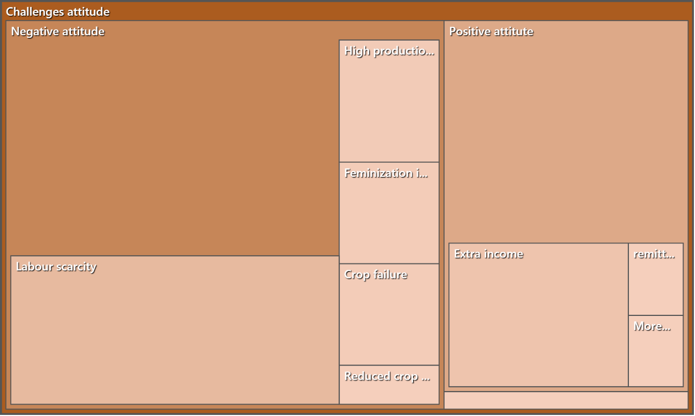

Figure 9 Comparison of attitude coding

Table 11 Attitude of migration challenges by participant type

|  |  |  |  |  |
| --- | --- | --- | --- | --- |
| Person | Mixed | Negative attitude | Positive attitute | **Total (unique)** |
| Participant type = Migrant (11) | 1 | 10 | 6 | 11 |
| Participant type = Non Migrant (13) | 0 | 9 | 8 | 12 |
| Participant type = Village Head (12) | 0 | 5 | 4 | 7 |
| Participant type = Head Level officer (4) | 0 | 1 | 0 | 1 |
| Participant type = Township level officer (10) | 1 | 5 | 1 | 5 |
| **Total (50)** | 2 | 30 | 19 | 36 |

Table 12 Name of participants from different participant type

|  |  |  |  |  |
| --- | --- | --- | --- | --- |
| Code No. | Migrant participant | Non-migrant participant | Village heads | Officers |
| 1 | Daw Aye Yee | Daw Aye Myint Kyi | U Aung Sein | Dr. Khaing Khaing Soe |
| 2 | Daw Khin My Thin | Daw Cho Cho Thin | U Aung Tin Tun | Dr. Nyi Nyi |
| 3 | Daw Kyi San | Daw Moe Aye | U Hla Myint | U Hla Myint Aung |
| 4 | Daw Myint Aye | U Aung Min | U Kyaw Moe Aung | U Soe Hlaing |
| 5 | Daw Naw Ni Khaing | U Hla Saw | U Kyi Myint Sein | Daw Ah Mar Kyi |
| 6 | Daw Po | U Ko Naing | U Nay Win Aung | Daw baby Win |
| 7 | Daw Pu Ma | U Kyaw Moe | U San Aung | U Aung Win |
| 8 | Daw Swe | U Kyaw Myain | U San Linn | U Aye Win Htun |
| 9 | Daw Than Than New | U Kyaw Shwe | U Saw Lwin | U Htay Thein |
| 10 | U Win Hla | U Mat Shye | U Soe Kyi | U Kyaw Kyaw Nyunt |
| 11 | U Win Hlaing | U Myant Moe Kyaw | U than Naing Oo | U Maung Maung Nyien |
| 12 |  | U Thin Soe Win | U Win Kyi | U Phyo Wai |
| 13 |  | U Win Shwe |  | U War So |
|  |  |  |  | U Zaw Htun |