Result and discussion
Research Question | Agreement in opinion | Conflicting Opinions | Discussion | Remark
What is the trend of migration in Myanmar? On the perspective of migrant or non-migrant households, village heads, administrative staffs | Most of respondents in village, township and country level agree that the increasing trend of migration is happening from the perspective of gender, migration status and also participant types.  Overall, the trend of migration changed significantly in both rather than the past in Myanmar, because of the infrastructure development especially in transportation, digital knowledge. Based on the data of 1983 census, migration was not a popular process in Myanmar due to less development of country’s infrastructure. Therefore, the defacto method, which is a concept under which individuals are recorded to the geographical area where they were present at a specified time, was selected for data collection in 2014 census due to the huge impact of increasing migration (Head level officer O2, DoP) . | However, some participants have different opinion with migrant population in their area especially low population migration place,  There is no change in migration trend in the village because agriculture is the major economic (Village head V10).  There is decreasing trend in migrant population in the village. The job opportunities especially in furniture industry because of urbanization that cause returning to the village (Village head V2). | Overall, the increasing trend of migration was happening in most places in Myanmar.  Nevertheless, some of less migrant population areas have no change or decreasing trend in migrant population because the job opportunity can create within the village from agriculture production and urbanization. | Refer to Figure 1, Figure 2, Table 1, Table 2
Why do migrants decide to move to other place? | Pull Factors  Most of the migrants become rich and develop their living standard (Farmer F12, Non-migrant),  The main reason of increasing of migrant population is the high gap between wage rate of destinations and original place (Township level officer O, DoA).  to invest the remittance in agriculture (Village head V1).  Push factors  The reasons of out-migration and leaving from agriculture are uncertainly of crop yield effect by climate change, unstable crop market price and demand, and not getting enough money from agriculture for household expenditure (Township level officer O5, DoA).  climate change and crop price fluctuation, for example, the price of green gram dropped dramatically last year and farmer response this effect by reducing the green gram sowing areas and migrating the outside of village to get extra income ( Township level officer O7, FMD).  This is the effect of transformation in Myanmar agriculture system. Farmers have substituted farm machines instead of farm labours in land preparation and crop harvesting, which are labour intensive job (Head level officer O4, FDM). |  | There are two factors as pull and push when mentioning the reasons of migration by participants.  Pull factors  - High wage rate  - Want of investment remittance in agriculture production  - Get better economic condition  Push factors  - Low income from agricultural production  - Uncertain market price and crop yield  - Low job opportunities  - Farm mechanization  - Effect Climate change on agriculture production  - Infrastructure development make more easier to migrate  - Don’t want to be farmer | Refer to Figure 3, Figure 4
Who made the decision to include in migration? | Family decided together to participate in migration for their sibling or household head in order to solve family money hardship or debt.  Family decided together for migration especially with father and brother ( Farmer F6, migrant family)  Family decided together for migration because of debt and low economic condition of family(  Farmer F22, Non-migrant family)  Moreover, household head especially male household heads also paly important role in decision-making process.  Household head play an important role in decision-making process for migration (Farmer F8, Migrant family)  However, gender unbalance was found in decision making process in the research refer to the table 3 |  | According to the culture of Myanmar, family decided together in making decision process. But male’s decision also influence and important within the family. | Refer to table 3
What kind of people or families are involving in migration process? | Not only farm families but also landless families with extra family members or not involving in migration process. For farm families, smallholder households mostly involved.  Smallholders farm households are more participated rather than that of large farm holders (Farmer F1, Migrant family).  In addition, landless households with less job opportunities and low incomes households are encouraged to participating in migration.  Landless and causal workers involved in migration process because of more comfortable and to get high income (Farmer F6, Migrant family)  If these family have extra family labour have more chance to migrate to other places  Households, which have large family size normally, are migrant households (Farmer F24, Non-migrant family). | On the other hand, large farm holder families especially young people also involve in migration process.  Large holders farm households also included to invest the remittance in agriculture (Village head V1). | 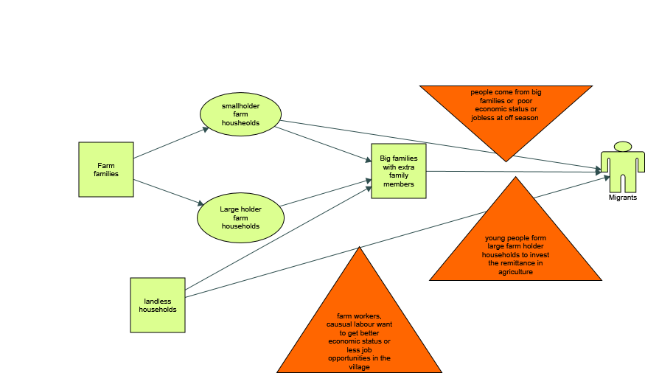  It can be concluded that both landless and farm families interest to involve in migration process with many reasons. | Figure 6,  Table 4
What are migrants’ characteristics? | Age range  Viewing the code from 33 cases of research, the age range of many migrants are 16- 30 years.  Gender  There are three classification concerning with gender of migrant as, equal ratio, female dominant and male dominant. Among them, the issue of male dominant migration was answered by 22 interviewees, especially in male non-migrant participants, male village heads, female migrant participants and in Sagaing Regions.  Education  Based on the coding of migrant education, many migrant have secondary school level from perspective of farmers especially from non-migrant households and village head | Gender  However female dominant migration and equal gender ratio of migration was found according to answer of 18 participants.  Education  Migrants who have high school level also involve in migration process. | Gender  The gender ratio of migrant population depend on destinations. Most female migrant population is found in domestic and male dominant migration is occurred for international.  For international migration, male is greater than female, but, female is outnumbered in domestic migration (Farmer F3, Migrant family).  Male population is higher in international migration and female population is greater in domestic migration (Farmer F16, Non-migrant family).  Education  The education level of migrant play an important role for selection of destinations.  Majority of domestic migrants are primary education level and the education level of international migrants varies based on destinations, for example, high school level will need for Singapore and Japan and just primary school level will require for Malaysia (Village head V8).  The main reason is the education level of migrants and low education level migrants usually move from rural to rural. Normally, the migrants who have high education level including government staffs always go from urban to urban ( Head level Officer O1, DoP). | Refer to Table 5,6,7,8
What are the common types/patterns of migration? | Types  Most of the migrants in the study areas. Even though international migrants who is working in China and Thailand (neighbour countries) usually return once per year.  Majority of migrants are temporary and they always come back to the village and stay in village about 15 or 1 month annually (Farmer F12, Non-migrant family).  Seasonal type of migration also as second popular item.  Most of domestic migrants are seasonal and they always return when there is no work in there (Farmer F9, Migrant family).  My husband usually return during peak season (Farmer F1, Migrant family)  Destinations  Concerning with the selection of destinations, the opinion of half of participants answered domestic dominants migration, which is common one in the study area.  Domestic migrants' population are greater than that of international migrants and most domestic migrants went to Taunggyi and Mandalay (Rural urban beyond district and within district (Farmer F7, Migrant family).  Domestic migration is popular in the village. The destinations for domestic migration are Yangon, Pharkant and Monya especially in off-season through connection of current working villagers (Farmer F16, Non-migrant family)  International migration has started this year and domestic migration have become a popular during off-season recently ( Township officer O6, DoA). | Destination  However, some participants against domestic dominant migration because they think international migration is more popular in their areas.  In the village, international migration (Bangkok) is the popular type of migration (Farmer F11, Migrant family).  International migration is more popular than domestic migration (Farmer F15, Non-migrant family) | Types  Most of domestic migrant are seasonal because there is no job opportunities during peak season in the village. Nevertheless, temporary migration type is more popular for both domestic and international migration.  Destination  Based on 2014 Census data, although domestic migrant population is greater than international migrant population, in the future, international migration must be more popular in Myanmar.  The international migrant population will have the increasing trend because most of domestic migrants are waiting at cross border area to go abroad as undocumented migrants (Head officer O1, DoP).  Future international migrants are attending the training in big cities to go South Korea (Village Head V1).  The person who came from Yangon introduced the international migration and connected job hunting agents and villagers. After that, the population of international migrants is higher than that of domestic migrants (Farmer F3, Migrant family). | Refer to Figure 7, 8, and table 9, 10
Step by step process of international and domestic migration | 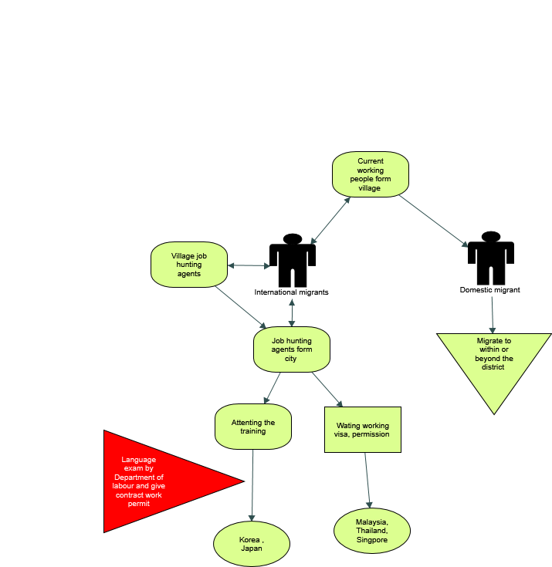  Figure 5 step by step process for international and domestic migration |  | Social network as current working people from the village play an important role in migration process especially for domestic migration.  For international migration, steps based on destinations (countries). If migrants want to Korea or Japan, they have to attend the language training and sit the exam for work permit and visa. However, for Thailand, Malaysia and Singapore, the job-hunting agent will assist to get work permission. | Refer to Figure 5
What are the issues/CHALLENGES?  Challenges faced by left behind family and community based on gender and participants' type. Strength, weakness, Opportunities, Threaten | 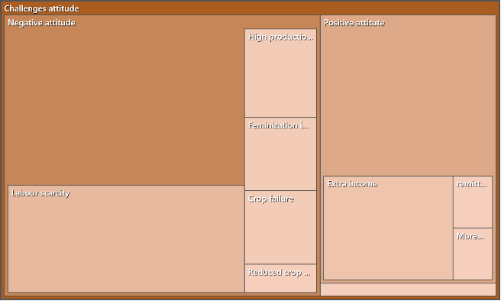  Figure 9 Comparison of attitude codes  Negative impacts of migration were occurred rather than positive impacts based on the attitude of interviewees. Among them, agricultural sector faced more difficulties not only individual but also community levels.  Among these agricultural negative effects, labour scarcity is the major important problem to solve immediately for agricultural development.  In agriculture, there are some difficulties in plantation especially in irrigation, harrowing due to hire more labours ( labour scarcity)( Farmer F14, Non-migrant family)  Labour scarcity has become a major impact of migration not only Myanmar but also around the world (Head Level officer O3, DoA).  Moreover, more participation of left behind women in managing agricultural production cause more burden for left behind women  Feminization agriculture would cause the delay of planting time and reducing yield. In my family, I have more burden in agriculture and household works such as looking after the children, housework and taking care of farmland etc (Farmer F1, Migrant family). | On the other hand, one-half of participants indicated the positive point of migration impact. The prominent impact is better economic condition for left behind families and community development.  There are many advantages such as repayment debt, buying farmlands for agriculture production, renovating house and getting more extra income (Farmer F8, Migrant family).  In addition, the causal and farm workers get high wage rate due to the reduction of farm labour in the village. Moreover, returnees also contribute in community development of village because young people gained more knowledge and experience from migration (Village Head V8)  Also women empowerment of left behind women improved than before migration process.  Left behind housewives is participating in decision making process of households’ economic activities (Farmer F13, Non-migrant family) | Normally, migrant families would got more benefit rather than non-migrant families because the adverse negative impact on agriculture may strike more farmers who depend only on agriculture income. | Refer to Figure 9 and Table 11

SWOT Analysis
Strength | Weakness | Opportunities | Threaten
- Economic development  The income and economic development is gained for migrant households (Village Head V6).  The rural economic development could see because of remittance for migration ( Township Officer O12, DoA)  - Infrastructure development  Migrants are contributing into the community development and fund of village (Village Head V11)  The village get electricity now due to the cooperating of migrants in community fund (Village Head V2).  - Educational development  Education sector of village would be developed due to more investment of remittance in education (Village Head V8)  - Ability or skill development  Young people who return form migration have more knowledge, experience and communication or social development (Township Officer O4, FDM) | - Reduction of labour force participation  The labour force of these areas significantly decreased and child and elderly population is dramatically increased. Human capacity/ labour force of Myanmar is reducing and the official income from remittance cannot calculate because of higher populated in undocumented migrants. Also skilled labour form the government sectors are migrating to the developed countries (Head Level Officer O1, DoP) .  - Decreasing of agricultural productivity  There are 30 households and 100 ac of sown area in the village, and if 10 households migrate to the other place, the labour force will reduced for 100-ac production in the village. Therefore, this effect may trigger the development of agriculture (Township Level Officer O11, DoA). | - Remittance investment  The remittance are used and invested in family business, this is one kind of opportunities for country (Head Level Officer O2, DoP).  - Social and community development  The village can get more job opportunities through social network of current working villagers (Village Head V6).  Social and community development was occurred especially in returnees because they gain a lot of experience and social communication with other people through migration (Village Head V8) | - Agricultural Underdevelopment  Reduction of agricultural sown area in the village (Village Head V1)  Reduction of agricultural productivity, low quality product and low land value (Township Level Officer O9, DoA)  - Low educational status  low educational status of citizen because many people dropped out at primary school level, and effect of climate change (Head Level Officer O1, DoP)  - Loss human capacity  Labour shortage and labour scarcity is the major problem. Whole families migration and skilled labour migration has caused the brain drain and brain streaming of country's human capacity (Head Level Officer O2, DoP)  - Youth Social and health problem  Most youngsters villages don't want to work hard and addict drug or alcohol when they return (Village Head V5)  Human trafficking, labour exploitation was occured at the border area of Thailand. Otherwise, in china border area, due to the impact of one child policy of China, unbalance sex ratio was happened and human trafficking concerning with bride import has become the major threaten for Myanmar (Head Level Officer O1, DoP).

Number of participants and their stakeholder relationship
Participant Types | Number of participants
Migrant farm household representatives | 11
Non-migrant farm household representatives | 13
Village heads | 12
DoA , Township level officers | 8
FMD, Township level officers | 2
DoA, Head level officers | 1
FMD, Head level officers | 1
DoP, Head level officers | 2

Formatting style of Quotations
Quotation Categories | Example of Representation
Quotation from key informant interview/ survey respondent | Lower case and indented
Quotation from interviewers | UPPER CASE, INDENTED
Identification numbered code for each farmer | e.g. F2
Identification numbered code for each village head | e.g. V3
Identification numbered code for each officer | e.g. O1
Points of clarification within quotes | (normal case, parenthesised)
Participant type identification number code | Normal case, parenthesised, numbered

